UPI Fraud Detection & Risk Analysis Using SQL, Power BI and Python

Documented by
Haritha B

Acknowledgement
I would like to express my sincere gratitude to my faculty guide for the valuable guidance and continuous support throughout the completion of this project. I also thank my department, friends, and family members for their encouragement and motivation.

Abstract
The rapid growth of digital payment systems and Unified Payments Interface (UPI) transactions has significantly increased the risk of fraudulent activities in online financial systems. Fraudulent transactions can lead to financial losses, security issues, and customer distrust.
This project focuses on analyzing UPI transaction data to identify fraudulent patterns and risky transaction behavior using SQL, Power BI, and Python.
A synthetic dataset containing around 8500 transaction records was generated to simulate real-world UPI transactions. SQL was used for data cleaning, preprocessing, and analysis. Power BI was used to create interactive dashboards and KPIs for fraud monitoring, while Python was used for data visualization and exploratory data analysis.
The project identifies fraud patterns using behavioral indicators such as failed transaction attempts, new device usage, night transactions, and transaction velocity. The dashboards and visualizations provide insights into high-risk transaction behavior and fraud trends.

Table of Contents
Introduction 3
Problem Statement 3
Objectives 4
Scope of the Project 4
Tools and Technologies 4
System Requirements 5
Dataset Description 5
Dataset Columns 5
Database Design 5
Fact Table 6
Dimension Tables 6
Methodology 6
Data Cleaning Process using SQL 6
Data Validation 7
SQL Analysis 7
Fraud vs Non-Fraud Transactions 7
Fraud by Location 7
Risk Level Distribution 7
High Risk Transactions 7
Power BI Dashboard Development 8
Dashboard 1: Fraud Overview Dashboard 8
Fraud vs Non-Fraud Donut Chart 8
Fraud by Location Column Chart 8
Fraud by Transaction Type Bar Chart 9
Dashboard 2: Risk Analysis Dashboard 9
Failed Attempts Analysis 9
Transaction Velocity Scatter Plot 10
Night Fraud Pie Chart 10
Dashboard 3: Device & User Behavior Dashboard 10
Fraud by Device Type 11
Fraud from New Devices 11
Heatmap Matrix using Conditional Formatting 12
DAX Measures and KPIs 12
Python Visualizations 13
Fraud by Location 13
Transaction Amount Distribution 13
Fraud by Transaction Type 14
Failed Attempts vs Fraud 14
Business Insights 14
Advantages 14
Limitations 14
Future Enhancements 14
Conclusion 15

Introduction
Unified Payments Interface (UPI) is one of the most widely used digital payment systems in India. It enables users to transfer money instantly using mobile devices. Due to the increasing usage of UPI systems, fraudulent transactions and cyber threats have also increased.
Fraud detection in financial transactions has become an important challenge for banks and payment systems. Identifying suspicious transactions manually is difficult because millions of transactions occur daily.
This project aims to analyze transaction data using SQL, Power BI, and Python to detect suspicious transaction behavior and identify fraud patterns.

Problem Statement
Digital payment systems generate a huge number of transactions every day. Detecting fraudulent activities among these transactions is difficult using traditional monitoring methods.
The problem addressed in this project is:
“To analyze UPI transaction data and identify potentially fraudulent transactions using data cleaning, dashboard analysis, and visualization techniques.”

Objectives
The objectives of this project are:
- To generate and analyze UPI transaction data
- To clean and preprocess data using SQL
- To identify suspicious transaction patterns
- To classify transactions into risk categories
- To create interactive dashboards using Power BI
- To perform visualization using Python
- To derive business insights from fraud behavior

Scope of the Project
The scope of this project includes:
- Fraud analysis in UPI transactions
- Data cleaning and preprocessing
- Dashboard creation using Power BI
- KPI analysis using DAX measures
- Visualization of fraud trends
- Risk analysis based on transaction behavior
The project can be further enhanced using machine learning models and real-time fraud monitoring systems.

Tools and Technologies
Tool/Technology | Purpose
SQL (MySQL) | Data storage and cleaning
Power BI | Dashboard creation and KPI analysis
Python | Data visualization
Pandas | Data manipulation
NumPy | Dataset generation
Seaborn | Statistical visualization
Matplotlib | Graph plotting
VS Code / Jupyter Notebook | Development environment

System Requirements
Hardware Requirements
Processor: Intel i3 or above
RAM: Minimum 4GB
Storage: 500MB free space
Software Requirements
MySQL Workbench
Python 3.x
Power BI Desktop
VS Code / Jupyter Notebook

Dataset Description
A synthetic dataset containing approximately 8500 transaction records was generated using Python libraries.

Dataset Columns
Column Name | Description
transaction_id | Unique transaction ID
user_id | User identifier
amount | Transaction amount
transaction_type | Type of transaction
device_type | Device used for transaction
location | City of transaction
time_of_transaction | Transaction timestamp
failed_attempts | Failed transaction attempts
is_night | Indicates night transaction
new_device | Indicates new device usage
transaction_velocity | Frequency of transactions
fraud_flag | Fraud indicator (0 or 1)

Database Design
The project follows a star schema model for Power BI dashboard development.

Fact Table
Fact_Transactions
Contains all transaction-related information such as:
transaction_id
amount
fraud_flag
transaction_velocity
failed_attempts
new_device

Dimension Tables
Dim_Location
Contains location details.
Dim_Device
Contains device type information.
Dim_TransactionType
Contains transaction type information.
Relationships
Dim_Location → Fact_Transactions
Dim_Device → Fact_Transactions
Dim_TransactionType → Fact_Transactions

Methodology
The project was completed in the following stages:
Dataset Generation
Importing Data into SQL
Data Cleaning and Preprocessing
SQL Analysis
Power BI Data Modeling
DAX Measure Creation
Dashboard Development
Python Visualization
Business Insight Generation

Data Cleaning Process using SQL
Data cleaning was performed using SQL queries.
Checking Null Values
SELECT * FROM transactions
WHERE amount IS NULL OR user_id IS NULL;
Removing Invalid Records
DELETE FROM transactions
WHERE amount <= 0;
Feature Engineering
A new column called risk_level was created.
ALTER TABLE transactions ADD COLUMN risk_level VARCHAR(20);
UPDATE transactions
SET risk_level =
CASE
WHEN failed_attempts >= 3 AND new_device = 1 THEN 'High'
WHEN transaction_velocity > 15 THEN 'Medium'
ELSE 'Low'
END;

Data Validation
Duplicate records were checked
Data consistency was verified
Invalid records were removed

SQL Analysis

Fraud vs Non-Fraud Transactions
SELECT fraud_flag, COUNT(*) FROM transactions GROUP BY fraud_flag;

Fraud by Location
SELECT location, COUNT(*) FROM transactions WHERE fraud_flag = 1
GROUP BY location;

Risk Level Distribution
SELECT risk_level, COUNT(*) FROM transactions GROUP BY risk_level;

High Risk Transactions
SELECT COUNT(*)FROM transactions WHERE failed_attempts >= 3
AND new_device = 1;

Power BI Dashboard Development
Three interactive dashboards were created using Power BI.

Dashboard 1: Fraud Overview Dashboard
KPI Cards
Total Transactions
Total Fraud Transactions
Fraud Percentage
Total Transaction Amount
Visualizations

Fraud vs Non-Fraud Donut Chart
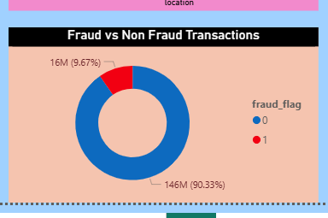

Fraud by Location Column Chart
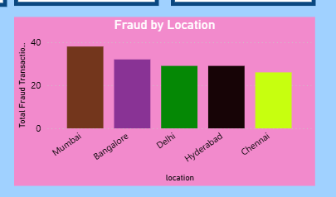

Fraud by Transaction Type Bar Chart

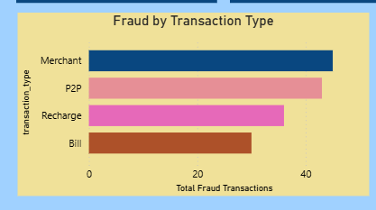
Slicers : Location, Device Type, Transaction Type

Dashboard 2: Risk Analysis Dashboard
KPI Cards
High Risk Transactions
Night Fraud Transactions
Average Failed Attempts
Visualizations

Failed Attempts Analysis
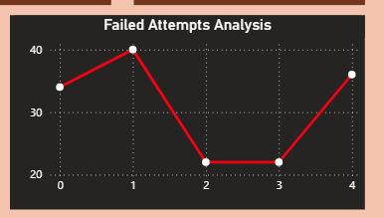

Transaction Velocity Scatter Plot
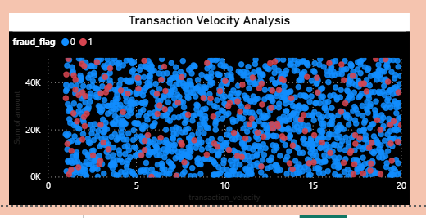

Night Fraud Pie Chart
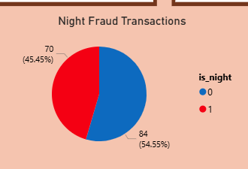
Slicers : Location, Device Type

Dashboard 3: Device & User Behavior Dashboard
KPI Cards
Fraud Amount
Fraud Rate
Maximum Transaction Amount
Visualizations

Fraud by Device Type
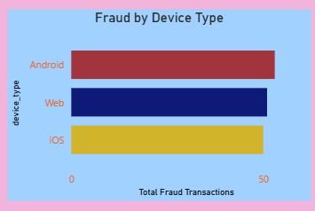

Fraud from New Devices
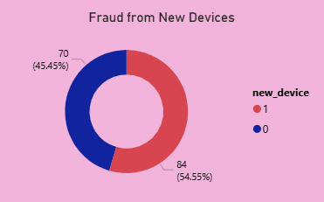

Heatmap Matrix using Conditional Formatting
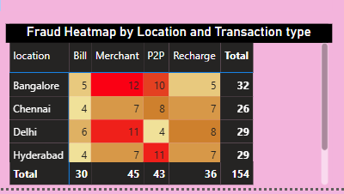
Slicers : Location, Transaction Type

DAX Measures and KPIs
Total Transactions
Total Transactions =
COUNT(Fact_Transactions[transaction_id])
Total Fraud Transactions
Total Fraud Transactions =
CALCULATE(
COUNT(Fact_Transactions[transaction_id]),
Fact_Transactions[fraud_flag] = 1
)
Fraud Percentage
Fraud Percentage =
DIVIDE(
[Total Fraud Transactions],
[Total Transactions],
0
) * 100
Total Transaction Amount
Total Transaction Amount =
SUM(Fact_Transactions[amount])
High Risk Transactions
High Risk Transactions =
CALCULATE(
COUNT(Fact_Transactions[transaction_id]),
Fact_Transactions[failed_attempts] >= 3,
Fact_Transactions[new_device] = 1
)
Fraud Amount
Fraud Amount =
CALCULATE(
SUM(Fact_Transactions[amount]),
Fact_Transactions[fraud_flag] = 1
)
Average Failed Attempts
Average Failed Attempts =
AVERAGE(Fact_Transactions[failed_attempts])

Python Visualizations
Python libraries such as Seaborn and Matplotlib were used for visualization.
Libraries Used
import pandas as pd
import seaborn as sns
import matplotlib.pyplot as plt
Fraud vs Non-Fraud Transactions
sns.countplot(x='fraud_flag', data=df)
plt.title('Fraud vs Non-Fraud Transactions')
plt.show()
Insight: Most transactions are normal while a smaller percentage are fraudulent.

Fraud by Location
sns.countplot(x='location', hue='fraud_flag', data=df)
plt.xticks(rotation=45)
plt.show()
Insight: Certain cities show higher fraud occurrence.

Transaction Amount Distribution
sns.histplot(df['amount'], bins=50)
plt.show()
Insight: Most transactions occur in lower amount ranges.

Fraud by Transaction Type
sns.countplot(x='transaction_type', hue='fraud_flag', data=df)
plt.show()
Insight: Some transaction types are more vulnerable to fraud.

Failed Attempts vs Fraud
sns.boxplot(x='fraud_flag', y='failed_attempts', data=df)
plt.show()
Insight: Fraudulent transactions generally show higher failed attempts.

Business Insights
The following insights were derived from the project:
- Transactions from new devices have higher fraud probability
- High failed attempts are strong indicators of suspicious activity
- Night transactions show increased fraud behavior
- High transaction velocity may indicate fraudulent activity
- Certain locations and transaction types are more vulnerable to fraud
- Behavioral indicators are more effective than transaction amount alone

Advantages
- Helps identify suspicious transaction behavior
- Combines SQL, Power BI, and Python in one project
- Provides interactive dashboards for analysis
- Demonstrates real-world fraud analytics
- Useful for business decision-making

Limitations
- Uses synthetic data instead of real banking data
- No real-time fraud detection implemented
- No machine learning model included
- Limited to analytical visualization

Future Enhancements
Future improvements include:
- Real-time fraud monitoring system
- Machine learning integration
- Power BI service deployment
- Advanced anomaly detection techniques
- Cloud database integration

Conclusion
This project successfully demonstrates how SQL, Power BI, and Python can be integrated to analyze fraudulent UPI transactions.
SQL was used for cleaning and preprocessing the transaction data. Power BI dashboards were developed to monitor fraud patterns, KPIs, and risk indicators. Python visualization techniques were used to understand transaction behavior and fraud trends.
The project highlights the importance of behavioral analysis in fraud detection systems and provides a strong foundation for future fraud analytics applications.

